MECH 463: EXPERIMENT 1

Lab Report

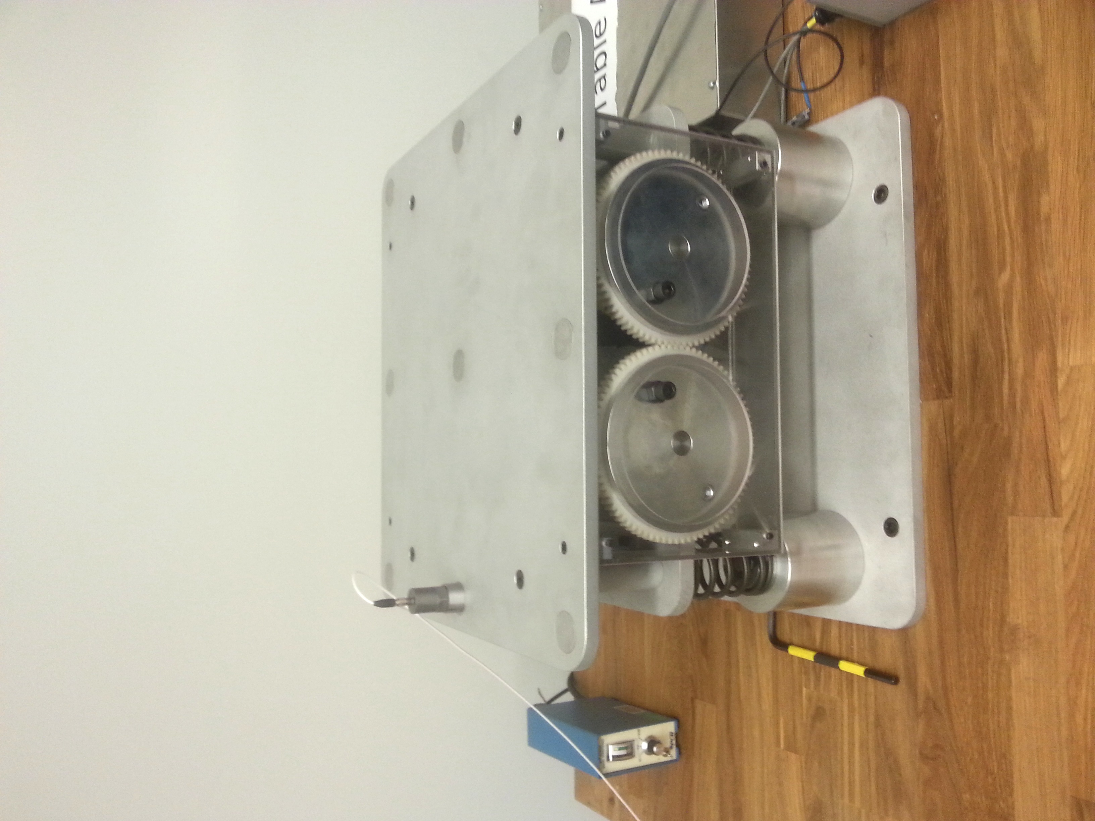

**Completed by**

Jordon Benner, 74424094

René Rinfret, 34929091

Table C (Oct. 10th)

**Presented to**

Masih Hanif, *TA*

Dr. A. Srikantha Phani, *Professor*

**Submitted on**

October 21st, 201

# Abstract

Vibrations are found in many applications in our physical world. From musical instruments to vehicles, and in activities such riding a bicycle or listening to music. Some vibrations are pleasant such as the harmonics produced by a skilled guitarist, while some are unpleasant such as turbulence during flight. This experiment was performed to increase our understanding of and appreciation for mechanical vibrations. In the experiment, a car engine, supported by four mounts using a mass supported by four springs and a viscous damper, was modeled. Rotating eccentric masses caused vibrations in this system.

During the experiment, an onboard accelerometer was used to record the acceleration felt by the supported mass through a range of input rotational speeds. Vibratory responses were measured and analyzed for two cases: the ‘In Phase’ case, where the rotating eccentric masses are synchronized to be at their highest points at the same time, and the ‘Out of Phase’ case where the masses are opposite from each other. These two cases produced different vibratory responses from the system.

Analyzing the response shows that they resemble theoretical predictions, deviating only on the low end of the frequency range where the noise was large. The measured natural frequency (9.3 Hz for In Phase Case) of the system was very close to the predicted natural frequency (9.64Hz), differing in that it was slightly larger than the theoretical value. This difference is likely because of the damping present in the system. Analysis of the damping present in the system showed that the Out of Phase case had a significantly smaller damping ratio than that of the In Phase case. This difference is due to the types of motion the apparatus experienced in both cases as well as the location of the viscous damper.

# Introduction and Methodology

This experiment was designed to expose UBC Engineering students to vibrations so that their effects can be readily analyzed. By developing a hands-on approach through a laboratory experiment, students can develop further appreciation for vibrations outside of the classroom and learn how to mitigate these effects in real life. Outside of the laboratory, Engineers must study vibrations since they have the potential to cripple structures, destroy mechanisms and cause machines to function improperly.

In this system, the phenomena observed is that of harmonic forces created by the rotation of masses that are not along the axis of rotation. Depending on the rotating speed of the system, an equivalent main frequency can be derived. When desiging a vibrating system, a key concern is that there is a possibility that the main (or excitation) frequency is similar in magnitude to the resonant frequency of the device, which can create large vibrations that can be damaging to the vibrating system. This phenomenon must be understood and accounted for when designing vibrating systems.

The apparatus in this experiment consisted of a mass supported by four springs and a viscous damper. During this experiment, rotating eccentric masses could be placed such that they rotate in phase and out of phase from each other. The system response was studied for each of those cases, as well as when the systems were at their resonant frequencies. This report will outline the findings of the experiment while contrasting theoretical predictions to the experimental data.

# Illustrative Diagrams with Components Indicated

The experimental apparatus was designed to be an approximate model of an automobile engine secured by engine mounts. Roughly, the apparatus consists of a box-shaped structure supported by 4 identical springs and a damper. Out of balance forces are created in the system by mounting two counter-rotating shafts, which have eccentric masses, secured to them. Specifically, the “Shaky Table” consists of:

* Disks, with attached eccentric masses which are fixed on parallel shafts
* A motor, to drive the shafts
* A persplex glass enclosure to house the components
* Four identical springs to mount the system
* A dashpot to provide a damping force in the system
* A tachometer to measure the speed of the motor
* A speed controller
* A Power supply
* An accelerometer mounted to the top surface of the device
* A Data Acquisition device to collect data from the accelerometer (DAQ module)
* A charge amplifier to amplify the data signal

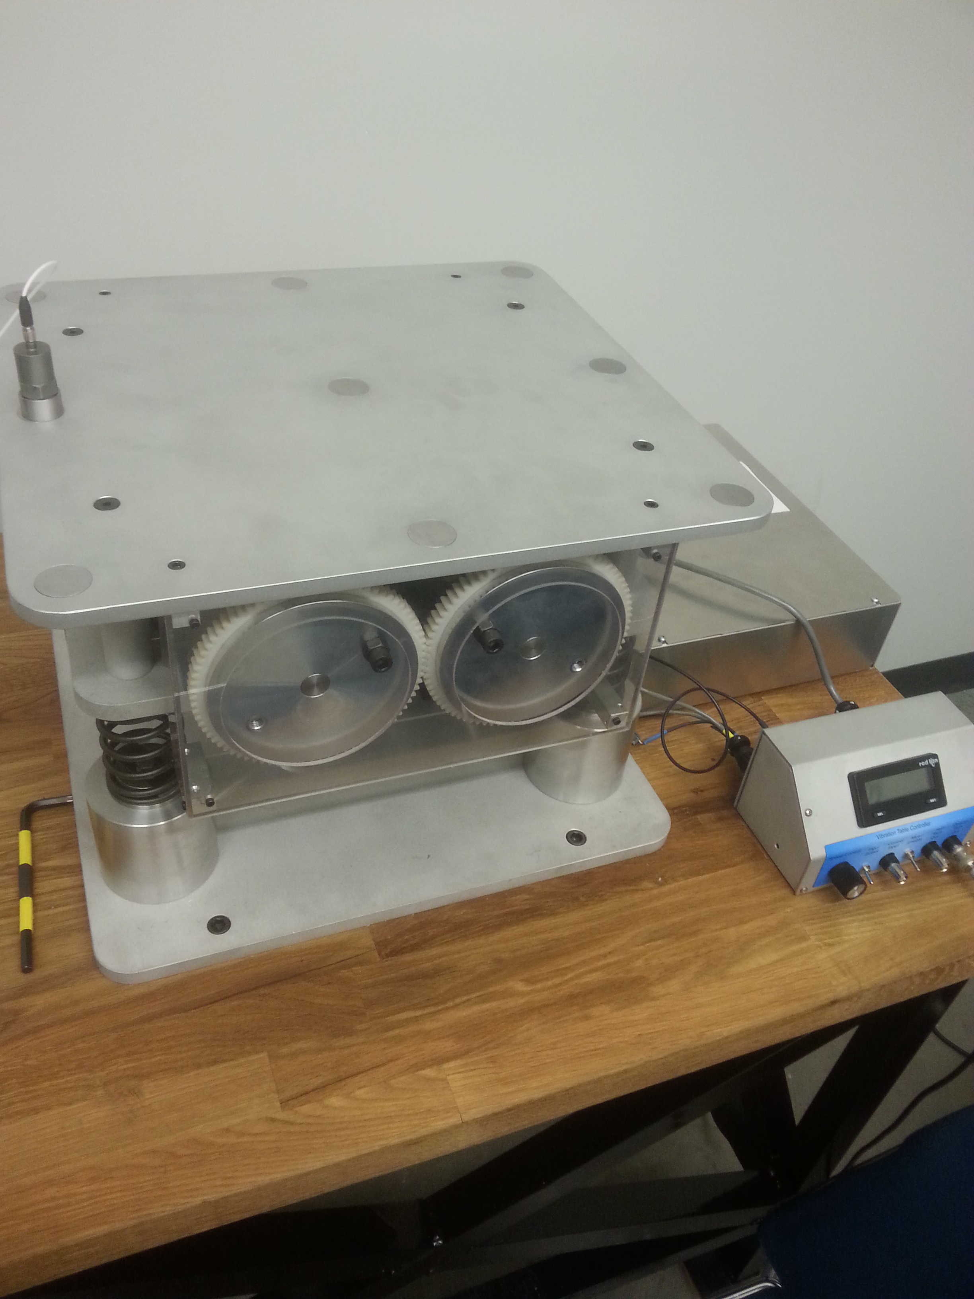

*Figure 1: Isometric View of Shaky Table*

Power Supply

Eccentric Masses

Accelerometer

Speed Controller

Springs

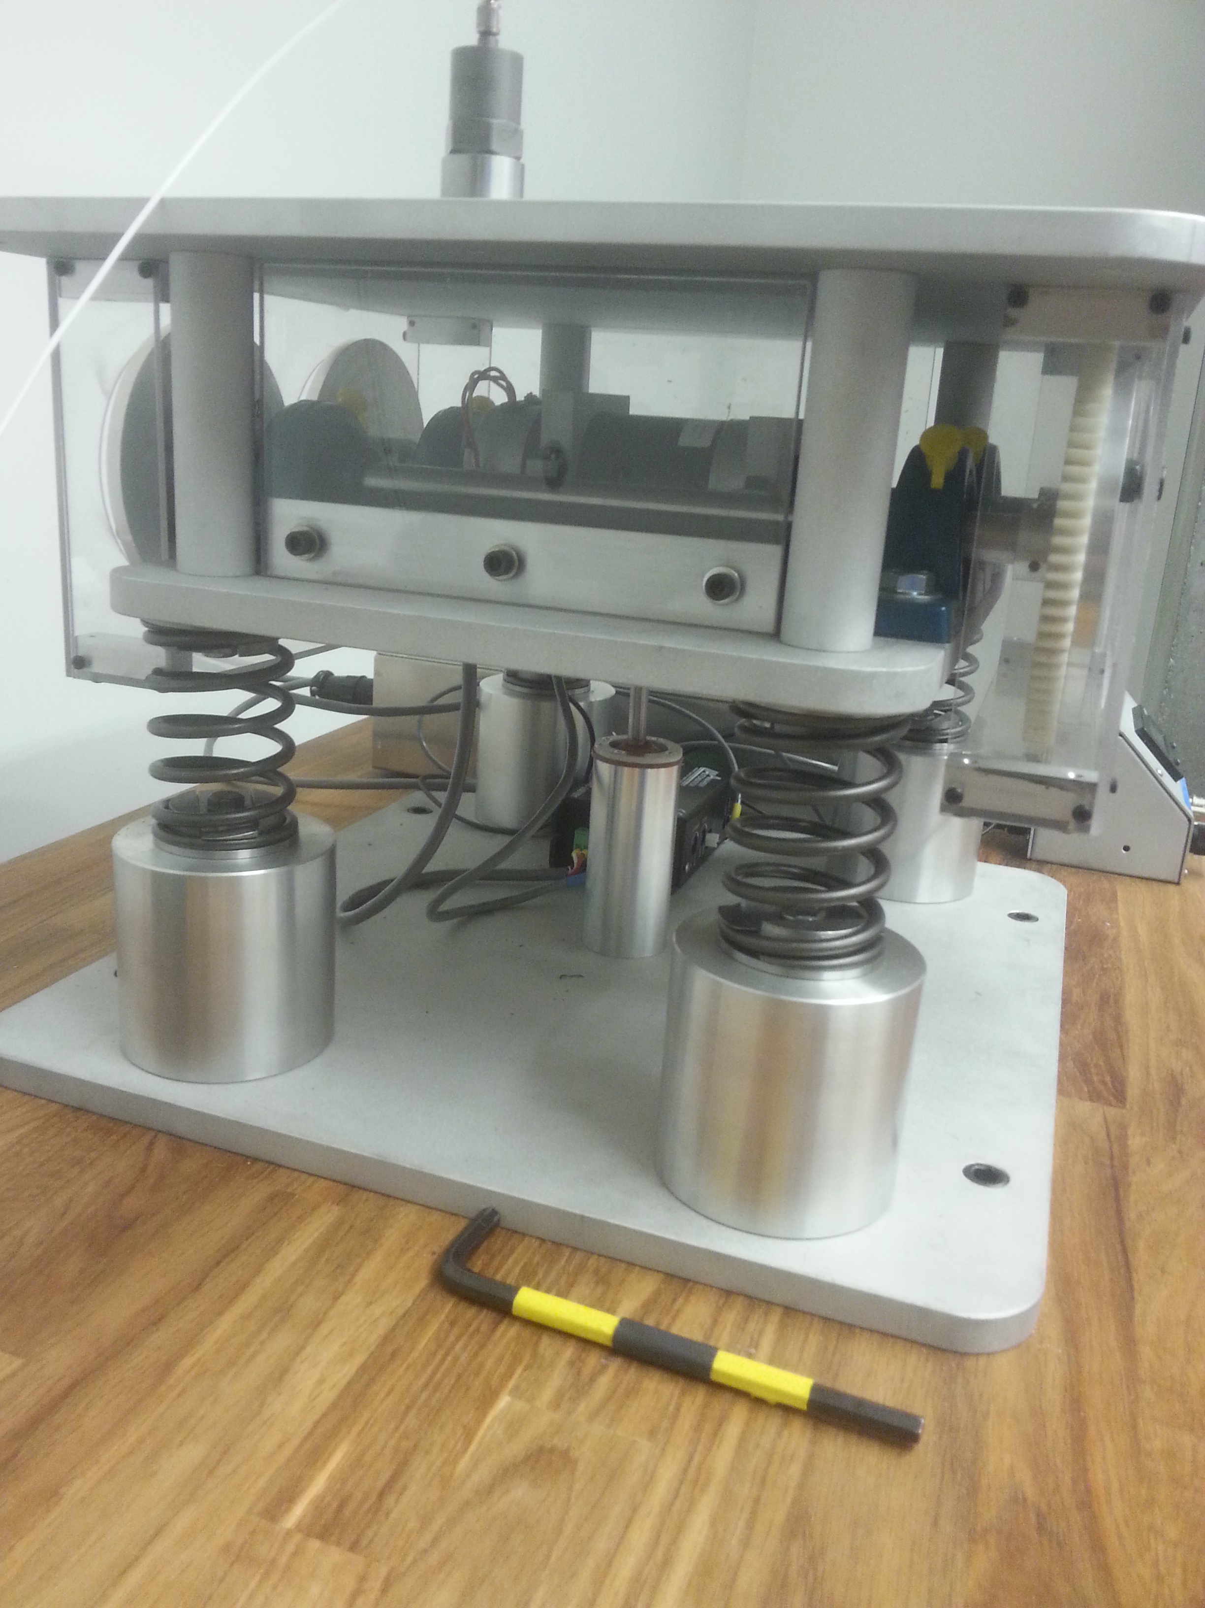

*Figure 2: Side View of Shaky Table*

Viscous Damper

Rotating Shafts

Motor

In addition, some key dimensions were both provided to us prior to the lab and manually recorded during the lab so that further, relevant calculations can be accurately derived. The Shaky Table used in this lab is from Table C (New Shaky Table). Its variables and their respective quantities are shown in Table 1.

**Table 1: Shaky Table Key Values**

|  |  |
| --- | --- |
| **Variable** | **Quantity** |
| Total Mass | 15.673kg |
| Mass of Accelerometer | 0.1kg |
| Mass of Damper Piston | 0.1134kg |
| Eccentric mass (each) | 0.0152kg |
| Calibration constant | 98mV = 1g = 9.8 $\frac{m}{s^{2}}$ |
| Distance between front and back disks | 0.34m |
| Radius of eccentric mass | 0.038m |
| Distance between front back springs | 0.204m |

# Results

## In-Phase

### Time Trace for Damping Ratio

To estimate the damping coefficient, we utilize the logarithmic decrement. First, we need a filtered response to analyze. Shown below is the filtered plot for the 9.3 Hz trial, which occurs very near to resonance.

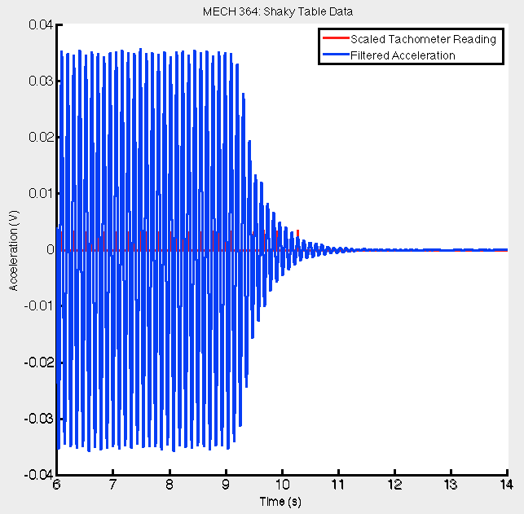

*Figure 3: Filtered Plot for 9.3 Hz Trial*

In order to obtain relevant information from Figure 3 and calculate the damping coefficient, a zoom-in is required (Figure 4) to obtain some amplitude values, which decays over time in this instance.



*Figure 4: Zoom-in of Figure 1*

Table 2 below illustrates the obtained values from graphical analysis using MATLAB. We can then calculate the damping coefficient using logarithmic decrement. For this part, the calculation of $δ$ was calculated comparing results from the first peak once the system decays with the fourth peak after that moment.

**Table 2. Measured Peak values from MATLAB**

|  |  |  |
| --- | --- | --- |
| Peak: | Amplitude (V) | Time (s) |
| 1 | 0.03495 | 9.096 |
| 2 | 0.03297 | 9.204 |
| 3 | 0.02789 | 9.314 |
| 4 | 0.01949 | 9.424 |

$δ=\left(\frac{1}{r}\right)\ln\left(\frac{A_{i}}{A_{i+r}}\right)$, where $A=\frac{\left(\left(Acceleration Amplitude \left[V\right]\right)\left(gravity \left[\frac{m}{s^{2}}\right]\right)\right)}{calibration \left[\frac{V}{g}\right]*Frequency^{2}{\left[\frac{rad}{s}\right]}^{2}}$

$$∴r=3→δ=\left(\frac{1}{3}\right)\ln\left(\frac{A_{1}}{A_{4}}\right)=\left(\frac{1}{3}\right)\ln\left(\frac{\left(\frac{\left(0.03495\right)\left(9.81\right)}{\left(0.098\right){\left(58.43\right)}^{2}}\right)}{\frac{\left(0.01949\right)\left(9.81\right)}{\left(0.098\right){\left(58.43\right)}^{2}}}\right)=0.195$$

$$∴ζ=damping ratio=\frac{δ}{2π}$$

$$ζ=0.031$$

### Typical Pre and Post Filtered Signal (Tachometer Signal)

Figure 5 is in-phase data obtained at 13Hz, and exhibits the general pre-filtered characteristics observed. In the figure, the blue signal is that of the accelerometer. This signal is clearly very noisy. Shown in red is the tachometer signal, whose amplitude is much greater than that of the acceleration shown.

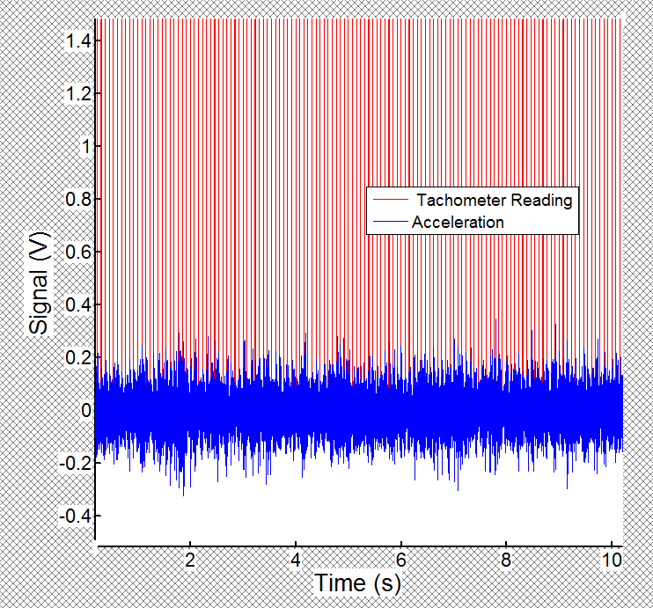

*Figure 5: Pre-Filtered Signals*

After applying a filter (post-filtered signal) to the tachometer signal, we are reducing the amount of noise it makes and are creating a much cleaner plot for the acceleration (Figure 6). A single relatively smooth line can then be viewed and better analyzed if we zoom in further (Figure 7).

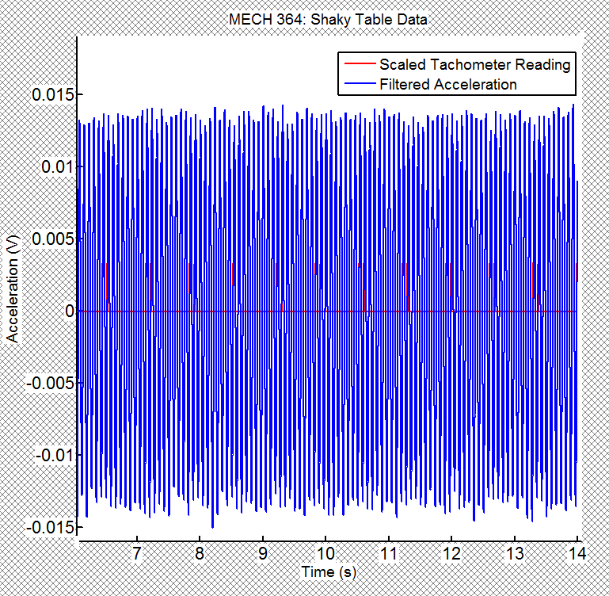

*Figure 6: Post-filtered Signals*

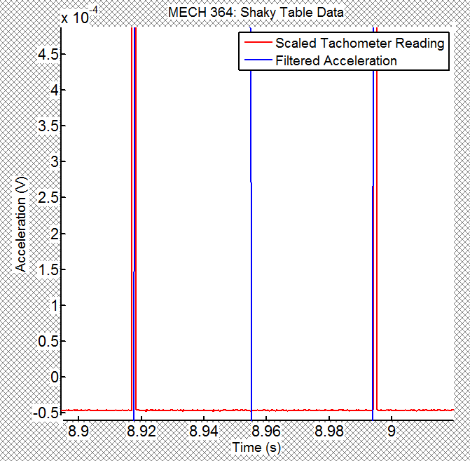

*Figure 7: Zoom-in of Post-Filtered Signals*

### Amplitude-Rotation Speed and Phase-Rotation Speed Graphs

During the experiment, a given MATLAB code generated phase angles and equivalent frequencies (in Hz) for each trial undergone. As a result, Figure 8 exhibits the Phase vs. Rotation Speed characteristics for in-phase trials. As expected, the phase angle decreases significantly after the resonant frequency (9.3Hz).

**Figure 8: Phase vs. Rotation Speed Results**

#### C.1 Acceleration Displacement Relation for Harmonic Motion

Displacement amplitude are then deduced by first converting obtained acceleration amplitudes (in Volts) to acceleration amplitudes in $\left(\frac{m}{s^{2}}\right)$ using the given relation, $0.098V=1g=\frac{1m}{s^{2}}$. Then, this acceleration amplitude is converted to displacement amplitude from the following equation for harmonic motions:

$$Displacement amplitude \left(m\right)=\frac{Acceleration amplitude \left(\frac{m}{s^{2}}\right)}{ω^{2} {\left(\frac{rad}{s}\right)}^{2}}$$

From this methodology, Figure 9 then illustrates the Amplitude vs. Rotation Speed characteristics for in-phase trials. As expected from theory, the highest displacement occurs at our obtained resonant frequency of 9.3Hz and is stable on both sides of the peak.

**Figure 9: Displacement Amplitude vs. Rotation Speeds Results**

### Hand Calculation for Phase and Comparison with MATLAB Results

Theoretical values for phase were calculated using the following relationships, and are displayed in Table 3.

$$ϕ [for frequencies<9.3Hz]=\tan^{-1}\left(\frac{2ζr}{1-r}\right)*\frac{180°}{π}$$

$$ϕ [for frequencies>9.3Hz]=\tan^{-1}\left(\frac{2ζr}{1-r}\right)*\frac{180°}{π}+180°$$

Where

$$ζ=0.031$$

And

$$r=\frac{ω}{ω_{n}}=\frac{ω}{\sqrt{\frac{k_{eq}}{m_{eq}}}}=\frac{ω}{\sqrt{\frac{\frac{57441.6N}{m}}{15.673kg}}}=\frac{ω}{60.54}$$

**Table 3: Calculated Theoretical Phase Values**

|  |  |  |  |
| --- | --- | --- | --- |
| rpm | Frequency (Hz) | r | Phase |
| 240 | 4.00 | 0.42 | 1.781 |
| 300 | 4.99 | 0.52 | 2.512 |
| 360 | 6.01 | 0.62 | 3.622 |
| 420 | 7.01 | 0.73 | 5.474 |
| 480 | 8.01 | 0.83 | 9.473 |
| 540 | 9.02 | 0.94 | 25.153 |
| 556 | 9.29 | 0.96 | 40.354 |
| 600 | 10.01 | 1.04 | 140.924 |
| 660 | 11.01 | 1.14 | 166.954 |
| 720 | 12.01 | 1.25 | 172.055 |
| 780 | 13.01 | 1.35 | 174.193 |
| 840 | 14.01 | 1.45 | 175.375 |
| 900 | 15.01 | 1.56 | 176.128 |

Therefore, we can compare the theoretical phases with the experimental phases, knowing that displacement phases are 180 $°$ apart from the phase leads for acceleration. Figure 10 shows the experimental data plotted against the calculated phases. The experimental data matches reasonably well against the theoretical values, except at ranges near the resonant frequency. In fact, the largest difference between the two curves occurred at the resonant frequency. This is possibly because it requires more time for the system to reach steady state near the resonant frequency (9.3Hz), since the displacement amplitudes are largest. However, we gave all frequency ranges tested the same amount of time to reach steady state.

*Figure 10: Theoretical vs. Experimental Values*

### Theoretical Prediction for Amplitude vs. Rotation Speed Relation

### Figure 9 demonstrated the experimental displacement amplitudes for the Shaky table. To obtain the theoretical displacement amplitudes in order to compare results, the following equations must be used:

$$Y=displacement amplitude=\frac{4me}{M}*\frac{r^{2}}{\sqrt{{\left[1-r^{2}\right]}^{2}+{\left[2ζr\right]}^{2}}}$$

Where

$$ζ=0.031$$

$$m=0.0152kg$$

$$M=15.673kg$$

$$e=0.038m$$

And

$$r=\frac{ω}{ω_{n}}=\frac{ω}{\sqrt{\frac{k_{eq}}{m_{eq}}}}=\frac{ω}{\sqrt{\frac{\frac{57441.6N}{m}}{15.673kg}}}=\frac{ω}{60.54}$$

Table 4 below illustrates calculations performed to obtain Y, the theoretical displacement amplitude.

**Table 4: Calculated Theoretical Displacement Amplitude Values**

|  |  |  |  |
| --- | --- | --- | --- |
| rpm | Frequency (Hz) | r | Displacement amplitude (theoretical) |
| 240 | 4.00 | 0.42 | 3.06819E-05 |
| 300 | 4.99 | 0.52 | 5.39786E-05 |
| 360 | 6.01 | 0.62 | 9.36944E-05 |
| 420 | 7.01 | 0.73 | 0.000165025 |
| 480 | 8.01 | 0.83 | 0.000325331 |
| 540 | 9.02 | 0.94 | 0.000946063 |
| 556 | 9.29 | 0.96 | 0.001484373 |
| 600 | 10.01 | 1.04 | 0.001557037 |
| 660 | 11.01 | 1.14 | 0.000613299 |
| 720 | 12.01 | 1.25 | 0.000409667 |
| 780 | 13.01 | 1.35 | 0.000324805 |
| 840 | 14.01 | 1.45 | 0.000278796 |
| 900 | 15.01 | 1.56 | 0.000250152 |

Finally, Figure 11 compares the theoretical and experimental results graphically.

*Figure 11: Experimental vs. Theoretical Displacement Amplitudes*

Similar to results from Figure 10,the experimental data from Figure 11 matches reasonably well against the theoretical values, except at some ranges above the resonant frequency (9-12Hz). This again is possibly because it requires more time for the system to reach steady state near the resonant frequency (9.3Hz).

### Out-of-Phase

Jordon, nigger

# Discussion and Conclusion

Jordon, nigger

# Questions to be Answered

1. **Can you list at least two differences between this experiment and the vibrations in a washing machine?**

One difference is the relative simplicity of our experiment compared to the washing machine. The washing machine has eccentric masses unevenly distributed as it spins, and has a large amount of fluid swirling around as well.

Another possible difference is that the washing machine is not rigidly mounted to the floor whereas the Shaky table is rigidly mounted. The rigid mounting of the Shaky Table likely dampens the vibrations considerably.

1. **How long must you wait between recording the data for two different RPMs?**

You must wait until the system reaches steady-state. According to our TA, this took about 15 to 20 seconds.

1. **Is the system lightly damped? Justify your answer.**

Yes, this system is lightly damped. This is evident when observing the motion of machine. The machine does not immediately return to rest, as you would expect with a critically damped system, nor does it stop oscillating and slowly return to rest as would be expected in an over damped system.

Instead, the system continues to vibrate with shrinking amplitudes as is consistent with an underdamped system. This conclusion is again evident when noting the estimated damping coefficients for both configurations. In both cases, they are less than 1, consistent with under damped systems.

1. **Explain why r=1 in Fig. A3 is not the location of maximum response.**

r =1 is not the location of maximum response due to damping in the system. Damping in the system shifts the peak to the right of r=1.

1. **Why does the width of pulse (channel 1 data in your measurements) change with rpm in readings from optical encoder (channel 1)?**

The width of the pulse changes with the RPM of the system because of the mounting of the Tachometer. During the lab, the TA demonstrated that the masses and shafts could be spun manually and that this would turn the tachometer light on as the mass passes the sensor. The sensor will remain activated for a few degrees of rotation. As the rotational speed increases, this lag is less evident. It is very similar to a bicycle computer (with wheel mounted magnet-sensors) in this sense.

1. **You can obtain different estimates for logarithmic decedent ±. Use these estimates to general the upper and lower bounding curves for the theoretical frequency response curve.**
2. **Equivalent models: For each typical resonance that you observed, deduce an equivalent spring-mass-dashpot model (from your measured damping) according to the following table given for in-phase case. The equation of motion for in-phase case can be expressed as $m\ddot{y}+c\dot{y}+ky=Fsin\left(ωt\right), F=4meω^{2}$. Develop an equivalent model for the dominant mode in the out-of-phase case. Indicate the appropriate units in the table.**